Chapter 5, Problem 1.

The equivalent model of a certain op amp is shown
in Fig. 5.43. Determine:
(a) the input resistance.
(b) the output resistance.
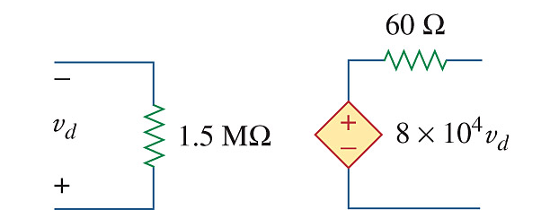
(c) the voltage gain in dB.

Figure 5.43
For Prob. 5.1.

